Name

Class

Date



Perimeters and Areas of Similar Figures

10-4

**Practice**

*Form G*

**The figures in each pair are similar. Compare the first figure to the second. Give the ratio of the perimeters and the ratio of the areas.**

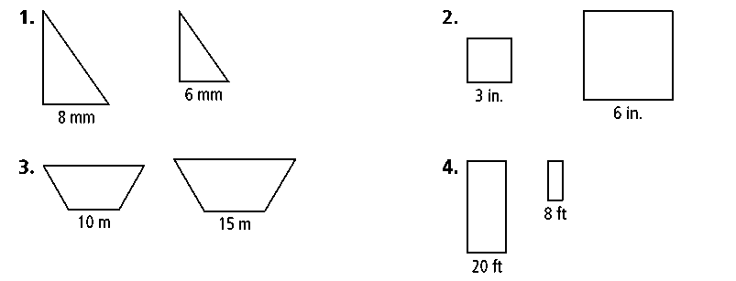**1. 2.**

**3. 4.**

**The figures in each pair are similar. The area of one figure is given. Find the area of the other figure to the nearest whole number.**

**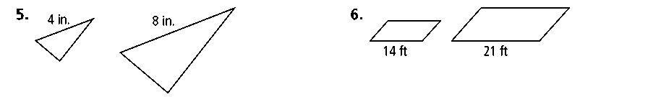****5. 6.**

area of smaller triangle = 12 in.2 area of smaller parallelogram = 72 ft2

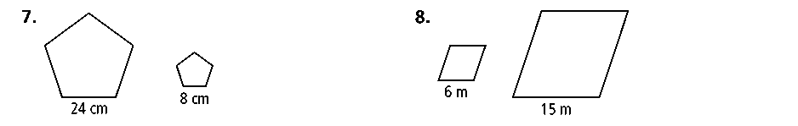**7. 8.**

area of larger pentagon = 135 cm2 area of smaller rhombus = 60 m2

**9.** It took James 5 h to paint an 8 ft by 24 ft wall. At this rate, how long would it take him to paint a 12 ft by 36 ft wall?

**Find the scale factor and the ratio of perimeters for each pair of similar figures.**

**10.** two regular pentagons with areas 144 in.2 and 36 in.2

**11.** two rectangles with areas 72 m2 and 50 m2

**12.** two regular pentagons with areas 147 ft2 and 12 ft2

**13.** two equilateral triangles with areas  cm2 and  cm2

**14.** two circles with areas 12π in.2 and 27π in.2

**Prentice Hall Gold Geometry •** Teaching Resources

Copyright © by Pearson Education, Inc., or its affiliates. All Rights Reserved.

**33**

Name

Class

Date



Perimeters and Areas of Similar Figures

10-4

**Practice** (continued)

*Form G*

**The scale factor of two similar polygons is given. Find the ratio of their perimeters and the ratio of their areas.**

**15.** 5 : 1 **16.** 2 : 7 **17.** 

**18.**  **19.** 10 : 3 **20.** 

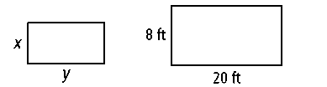**Algebra Find the values of *x* and *y* when the smaller similar rectangle shown here has the area given.**

**21.** 10 ft2 **22.** 20 ft2 **23.** 22.5 ft2

**24.** 40 ft2 **25.** 44.1 ft2 **26.** 50 ft2

**27.** The area of a regular octagon is 45 ft2. What is the area of a regular octagon with sides  the length of sides of the larger octagon?

**28.** The longer base of a right trapezoid is 12 ft. The longer base of a similar right trapezoid is 30 ft. The area of the smaller right trapezoid is 20 ft2. What is the area of the larger right trapezoid?

**29.** A postcard costs $0.95. Leslie wants to buy a poster that is a similar shape with a scale factor for the poster to the postcard of 5 : 1. How much should she expect to pay for the poster?

**30.** Two similar parallelograms have areas 125 m2 and 80 m2. The height of the larger parallelogram is 10 m. What are the lengths of the bases of both parallelograms?

**31.** A team is excavating an archeological site. The original plan was to excavate a rectangular area 35 ft long by 20 ft wide. Instead, the team decided to excavate a similar rectangle that is 50 ft wide. Find the length and the area of the new rectangle.

The pair of figures is similar. Compare the larger figure to the smaller figure. Find the ratio of their perimeters and the ratio of their areas.

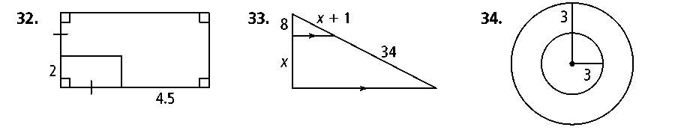**32. 33. 34.**

**Prentice Hall Gold Geometry •** Teaching Resources

Copyright © by Pearson Education, Inc., or its affiliates. All Rights Reserved.

**34**